Application Testing IDE Structure

First I installed the Android studio and configured the environment so I can start recording with Espresso to create the necessary testing. I created a basic application with a check box and a button, tried Espresso and worked fine since it records every action that I made on the owned application.

Then as instructed, I downloaded manually the Vodafone app, on the android emulator and till now its fine, but when I tried to use the Espresso on the Vodafone app, problems occurred. It did not record any events and from the research that I made, Espresso is not the ideal tool to use for third party apps. I found out that one needs to install extra driver to the Android Studio like Robotium and Appium but things went to worse since that I tried to install the rivers but the IDE starts crash.

After a good research and trying different setups, I found that Appium has their own Studio environment which is Appium Studio, which is shown below and it`s free.

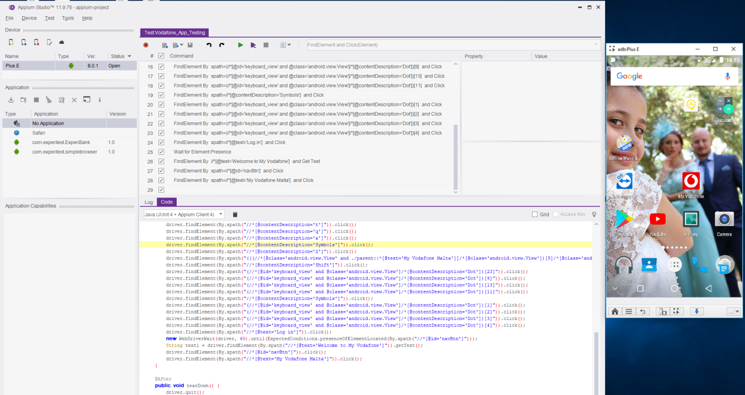

They have the paid version, which gives the possibility to access their cloud to have multiple different devices to test on. I have used the free version since it`s enough for my requirements.

I have used this environment to create the tests required, and I found it very useful since it can record action for testing, play test, and creates testing report for every action and the emulator can be a mirror image of my mobile.